# A Practical Report for

BUGGY PROJECT (UTA - 011)

by

**Shivam Mittal - 101603316**

# Submitted to

**Dr. Kunal Singh**



## ELECTRONICS AND COMMUNICATION ENGINEERING DEPARTMENT THAPAR INSTITUTE OF ENGINEERING AND TECHNOLOGY

**PATIALA - 147004 PUNJAB INDIA**

**January-June 2018**

**Experiment: II**

**Objective:**

1. To design a schematic diagram of pulse width modulation (PWM) transmitter circuit for gantries placed at different locations on the path to be followed by the Buggy robot.
2. To design a Printed Circuit Board layout of pulse width modulation (PWM) transmitter circuit for gantries placed at different locations on the path to be followed by the Buggy robot.

**Software Used:** Eagle software.

**Components used:**

|  |  |  |  |
| --- | --- | --- | --- |
| **Sr. no.** | **Name of component** | **Value** | **Specifications** |
| 1. | Resistor | 220 Ω | Carbon resistor with 5% tolerance |
| 2. | Capacitor | 1000 n F | Electrolytic capacitor |
| 3. | Capacitor | 10 n F | Electrolytic capacitor |
| 4. | DCJ0202 |  | DC power jack |
| 5. | ZHCS2000 | 5V | Schottky Diode |
| 6. | IC 78L05Z | +5V | Positive voltage regulator |
| 7. | 22-23-2031 |  | PCB header |
| 8. | PIC12F629 |  | Microcontroller |

**Circuit diagram**: (sketch by hand)

**Theory**: (brief description about each component used in circuit diagram and working operation)

**Components used:**

1. **Resistor:** A resistor is an electrical component that provides resistance to the flow of current in a circuit. The amount of current flowing through a certain resistor is proportional to the voltage across its terminals.

***V=IR (Ohm’s Law)***

Resistors have a certain color coding to enable the user to read its value. A chart for the same is provided below

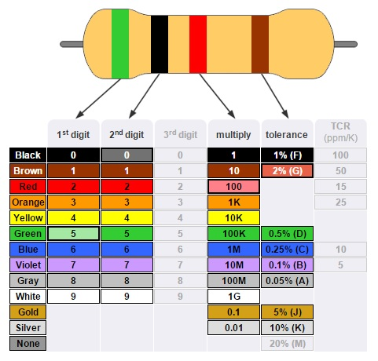

1. **Capacitor:** A capacitor is an electrical component used to store charges for short intervals of time. The value of capacitance is given by

***C=ԐA/d***

Where C is the capacitance,

A is the cross sectional area of the plates

And Ԑ is the permittivity if the medium in between the plates.

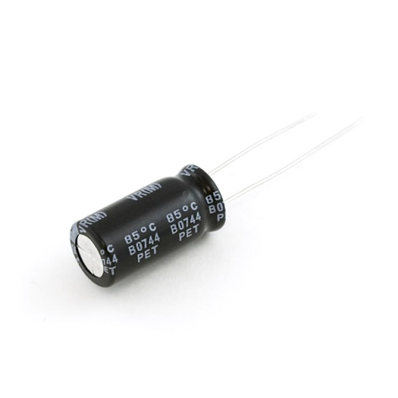

1. **DCJ0202:** It is a DC power jack primarily used for the transmission of wall current transformed to DC power, for detached and hand held instruments

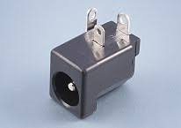

1. **ZHCS2000:** It is a Schottky barrier diode featuring low forward voltage drop suitable for high frequency rectification and reverse voltage protection.

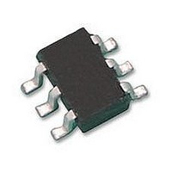

1. **IC 78L05Z:** It is a voltage regulator that provides 5V output voltage and 100mA output current.

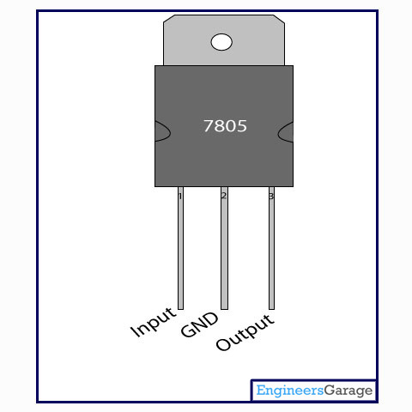

1. **PIC12F629:** It is an 8-bit microcontroller. The device has a 13-bit program counter capable of addressing an 8K x 14 program memory space.

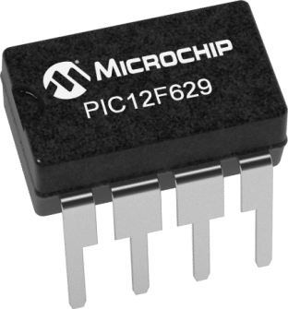

**Working:**

The microcontroller generates the PWM signal that is characteristic of the gantry. This PWM signal is then sent to the IR LED to transmit it as an IR signal which can then be detected by the PWM receiver circuit designed earlier.

There is a voltage regulator circuit attached to ensure that the microcontroller gets a continuous supply of 5V. This circuit consists of a voltage regulator IC, capacitors and a DC jack for power input.

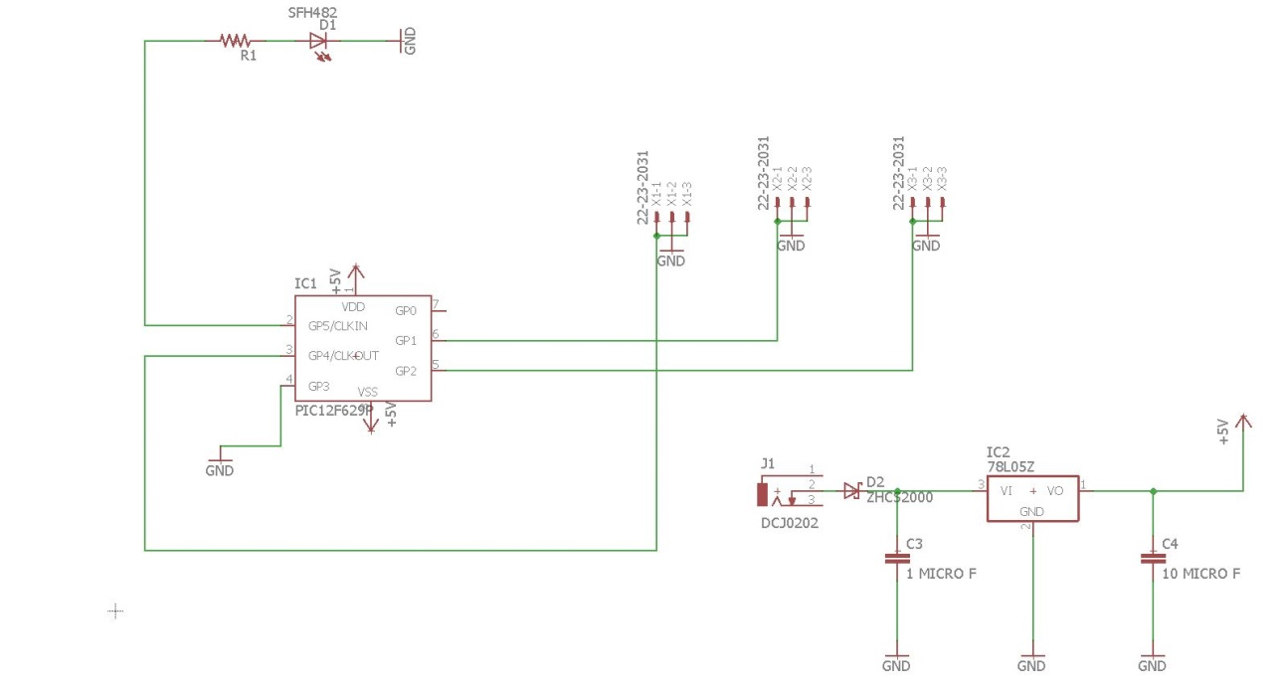**Schematic diagram**: (from Eagle software)

**Printed Circuit Board layout**: (from Eagle software)

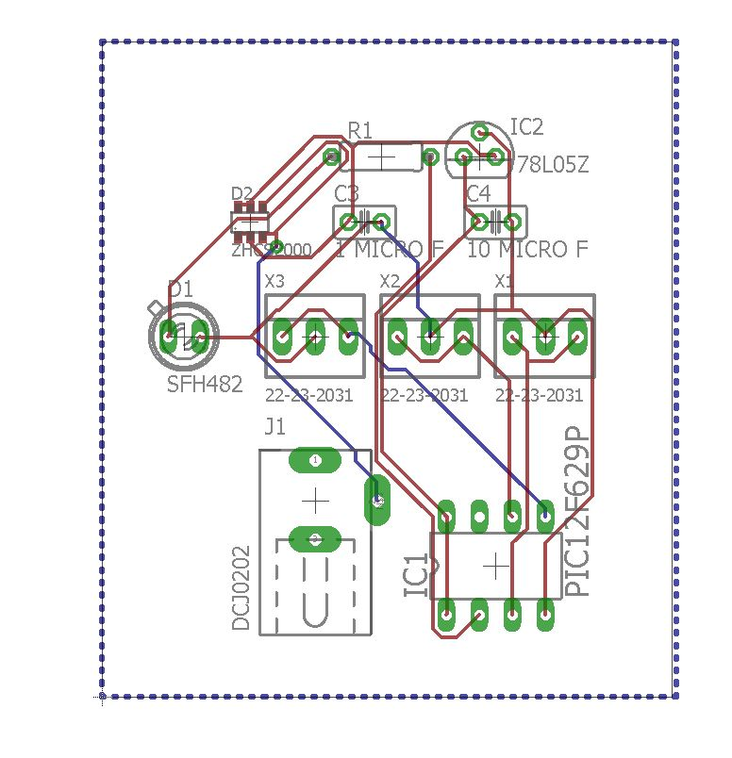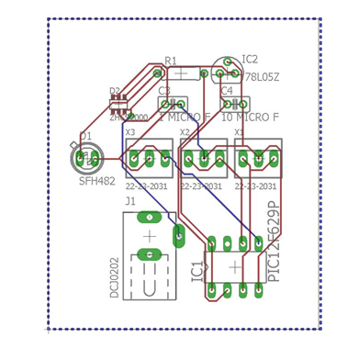

**Discussion:** Here, we learned how a simple circuit can be used to generate a PWM signal of a particular width. This transmitter circuit can then be put on gantries and can be sensed by the buggy using the receiver circuit. As a result, the buggy can be made to follow the path assigned to it.

**Signature:** …………………………………………………